Sprint Report 1
  - Portfolio task 2/3/4
Unit code: EAT40005
Unit Name: Engineering Project A
Submission date: 28/04/2025

Student Name | Student Id | Statement of contribution to the report
Senupama Damdini Deshapriya | 104329709 | Contributed Sprint Plan and Sprint Progress fields, coordinated team reports, and helped compile report structure as a whole.
Chrishelle Anthoneyz | 104067504 | Contributed Sprint Demonstration and helped with Sprint Review and Retrospect fields. Helped coordinate client meeting inputs.
Haritha Manuja Perera | 104207449 | Contributed Lessons Learned and helped with Sprint Review analysis, including client input incorporation.
Thenura Dulnath Kuruppuarachchi | 103512993 | Contributed Retrospect and helped with Sprint Review field, including critical evaluation of group process problems and improvements.

Acknowledgment of Country
Each team member identifies the Traditional Owners of the land they lived on while completing this work.
- Senupama Damdini Deshapriya acknowledges the Wurundjeri Woi Wurrung people as the Traditional Owners of the land they lived on while completing this work in Melbourne, Victoria.
- Chrishelle Anthoneyz acknowledges the Wurundjeri Woi Wurrung people as the Traditional Owners of the land they lived on while completing this work in Melbourne, Victoria.
- Haritha Manuja Perera acknowledges the Wurundjeri Woi Wurrung people as the Traditional Owners of the land they lived on while completing this work in Melbourne, Victoria.
- Thenura Dulnath Kuruppuarachchi acknowledges the Wurundjeri Woi Wurrung people as the Traditional Owners of the land they lived on while completing this work in Melbourne, Victoria.

SPrint plan
Our client Alex Jaimes Castillo from Swinburne University of Technology is spearheading the LIDA project, which targets sustainable composting via a smart, sensor-activated system. Our task is to create a fully labeled, colored, and animated 3D model of the LIDA composting system for improved user interaction, education, and app integration. The LIDA composting unit project intends to develop an intelligent, user-friendly composting system capable of efficiently processing household organic waste. The system integrates mechanical aeration, distinct chambers for different composting phases (active, curing, and final collection), and sensor-based monitoring (temperature, humidity, gas, and movement) to improve the composting process. The goal of Sprint 1 was to design the complete physical framework and initial naming needed for further animation and functionality during Sprint 2.
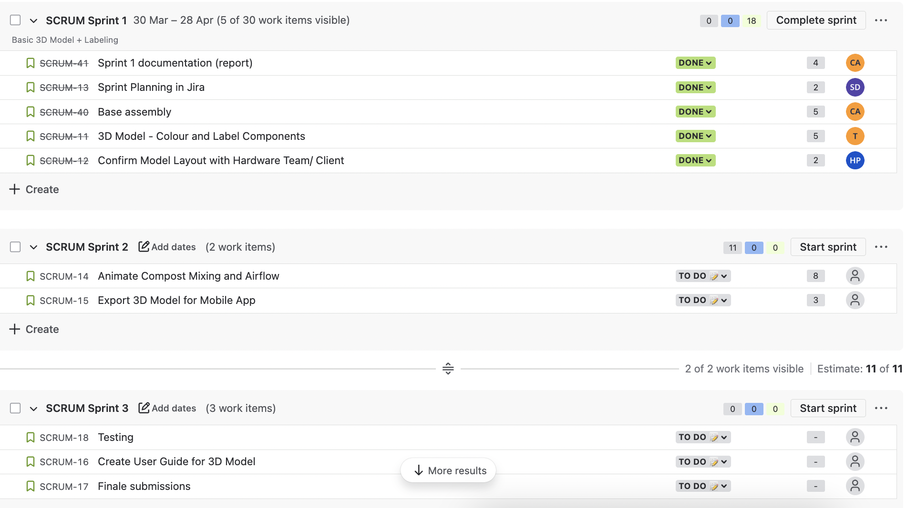
Product Backlog overview showing the full set of user stories planned for the LIDA composting system project

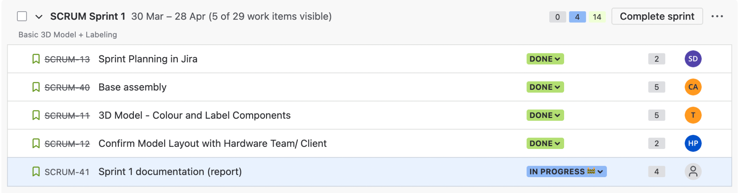
Sprint 1 Backlog highlighting tasks selected for execution during the first development sprint.

SPrint progress
At the start of Sprint 1, we established a comprehensive product backlog in Jira, prioritizing essential modelling and planning tasks required for successful project progression. Key tasks selected for Sprint 1 included the creation of the base assembly, chamber structures, sensor placeholder positioning, initial colour coding of different composting phases, and early animation logic preparation.
Throughout the sprint, tasks were divided into manageable subtasks linked to major user stories. Each subtask was assigned appropriate story points based on estimated complexity. Progress was tracked weekly through Jira, ensuring visibility on task completion and highlighting any risks or blockers early.
By the end of Sprint 1:
- Base component modeling (chambers, frames, piping) was completed.
- Initial colour coding was implemented (Red for Active Phase, Green for Curing Phase, Brown for Final Compost Collection).
- Preliminary labelling for input/output ports, sensors, and chambers was applied.
- Basic animations (e.g., lid opening mechanism) were initiated.
Overall, Sprint 1 successfully delivered the key objectives of establishing a complete 3D model framework ready for animation and interaction development in Sprint 2.

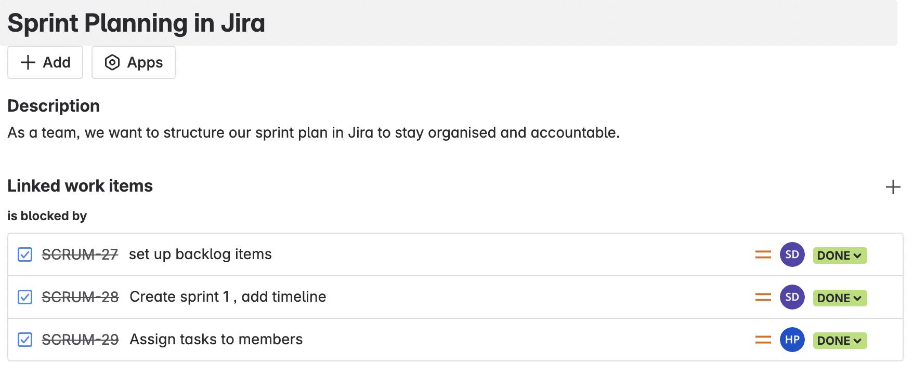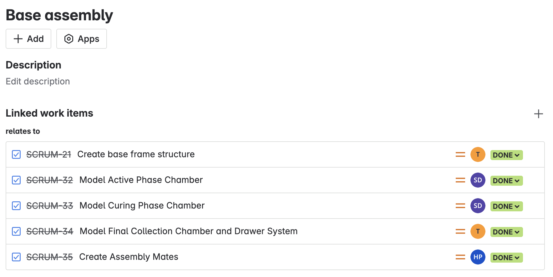
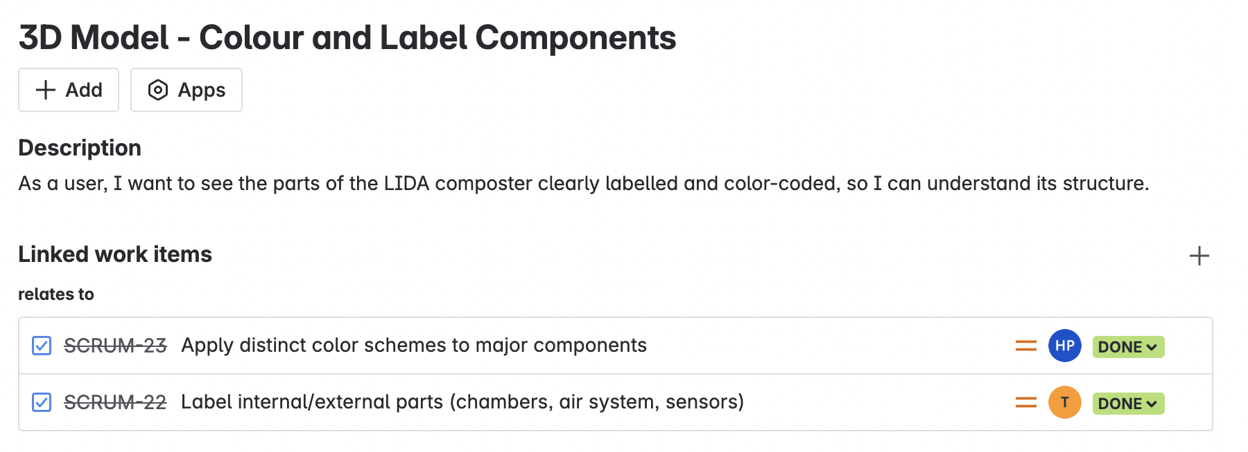
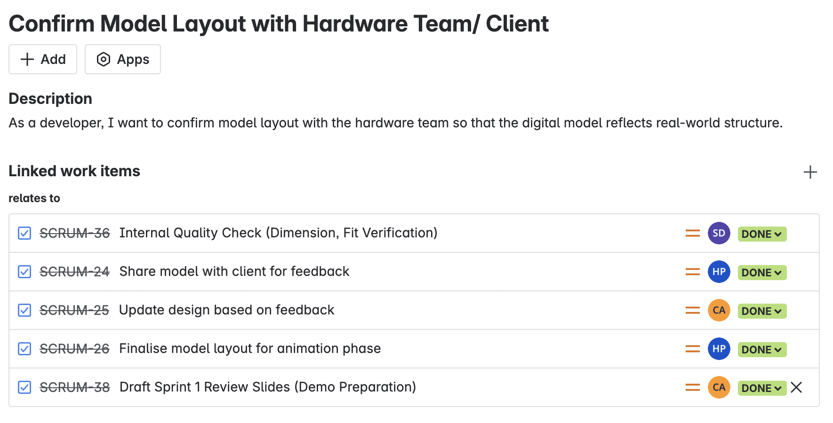
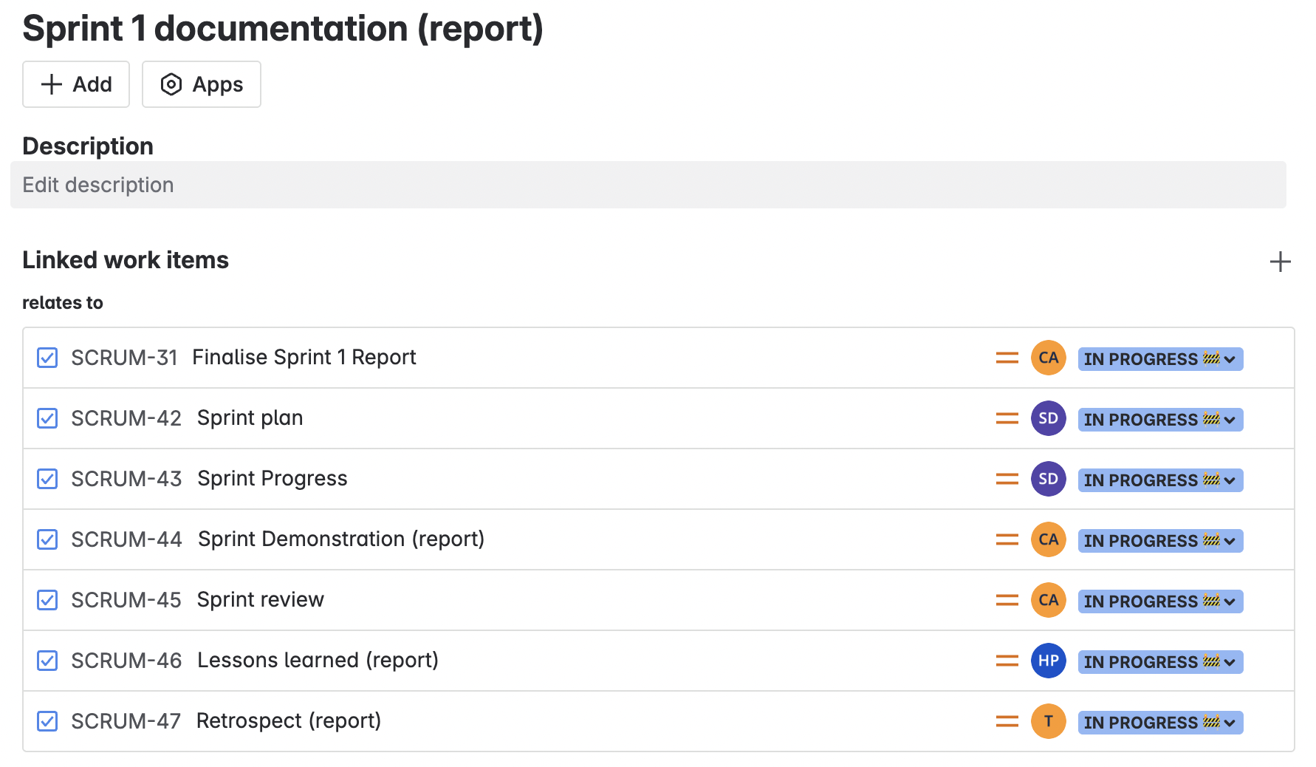
Mapping of subtasks linked to major user stories for structured sprint workflow.
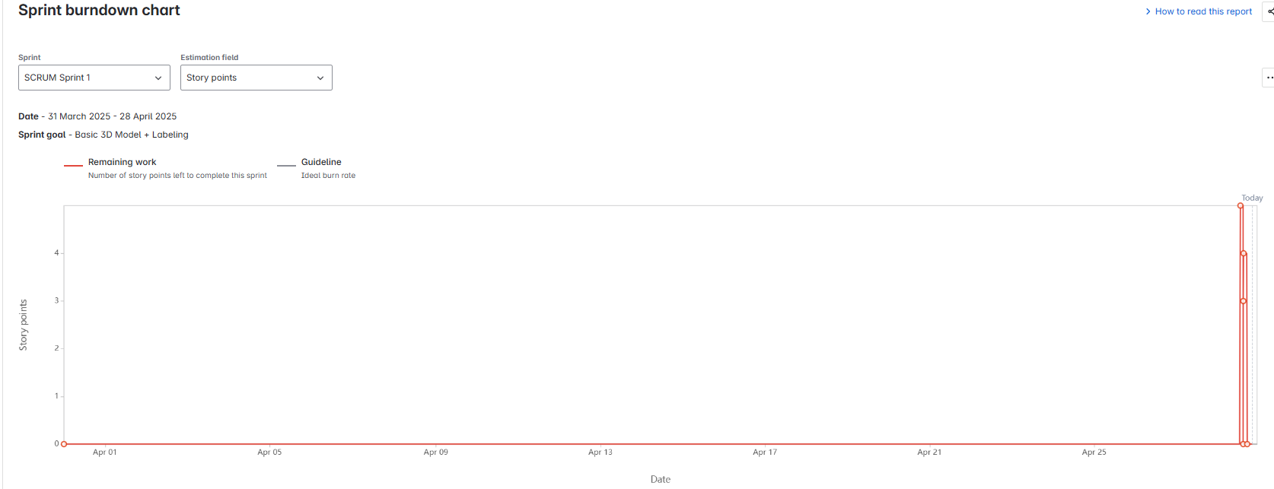
Sprint 1 Burndown Chart reflecting task completion over the sprint timeline.

Sprint Demonstration
The demonstration for Sprint 1 took place on Thursday, the 24th of April 2025 between 4:30 PM to 6:00 PM in Room AD324, Swinburne University of Technology. All members in our group Senupama Deshapriya, Thenura Kuruppuarachchi, Chrishelle Anthoneyz, and Haritha Manuja Perera were present including our client Alex Jaimes Castillo.
The demo session began with the hardware team presenting the physical model of the LIDA composter. Our client, Alex Jaimes Castillo, explained the composting process in detail, highlighting significant portions of the prototype: Active Phase, Curing Phase, and Final Compost Storage. After the hardware demo, our software team demonstrated the SolidWorks 3D model created during Sprint 1. The SolidWorks model was an in-depth virtual copy of the LIDA composter, designed to mirror the actual prototype and also imagine future app integration opportunities.
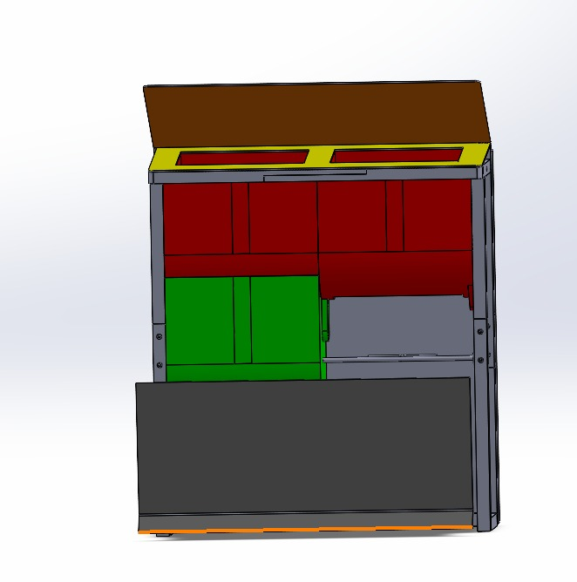
Solidworks 3D model side and front views
Our software team demonstrated the SolidWorks 3D model, pointing out its key features:
- Chambers were properly color-coded for identification (Red for Active Phase, Green for Curing Phase, and Brown for Final Phase).
- Accurate Labelling and Placement: Input/output ports, airflow tube placements, and technical module spaces were clearly marked and labelled.
- Material Identification: Transparent and metallic surfaces were copied in the 3D model to accurately replicate the prototype structure.
- Early Animation Development: First-stage animations showed lid opening/closing mechanisms and paddle motion, indicative of working dynamics within the composting system.
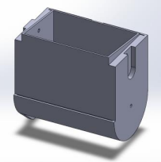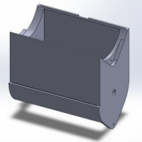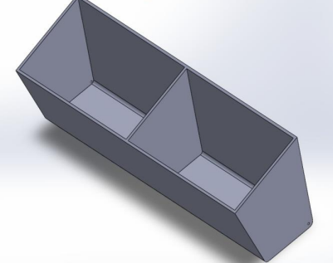
Solidwork model Parts
Working with SolidWorks provided an easy and interactive way of understanding the system elements, the movement of its mechanism, and all the sensor locations. This was of great significance in helping the client better understand the internal structure and functioning of the composter more easily.
The client appreciated the overall structure as well as the alignment of design. There were some minor recommendations:
- Increase chamber separation to improve user visualization.
- Make sensor placements even more prominent for the next sprint.
- Get animation of the mechanical elements (paddles and gates).
In general, the demonstration was successful in supporting the project goals for Sprint 1. The client was satisfied with the work so far and gave good feedback for adjusting during the next sprint period.

Sprint review (Critical review of the product)
Our group is working on a project that involves the creation and design of a 3D interactive SolidWorks model of a smart composting system known as LIDA. The composting system is an environmentally friendly in-vessel composting system with multiple compartments for active and curing phases, internal piping, mixing motors, temperature and gas sensors, and automated lid mechanisms. Our group-specific project for this semester is working into redesigning, colouring, labelling, and animating the 3D model, with integrating it into a mobile app if time permits.
Demonstration Details
Date: 24th April 2025 (Thursday)
Time: 4.30 PM to 6.00 PM
Venue: AD324 Meeting Room, Swinburne University
Attendees: Alex Jaimes Castillo (Client) ,Group 2 Members (Haritha Perera, Chrishelle Anthoneyz, Senupama Deshapriya, Thenura Kuruppuarachchi), Hardware Teams
For this demo, the client accompanied a prototype of the composter, explained each compartment in detail (active phase, curing phase, waste collection mechanism), and explained the process of composting in general. After the tour, our team provided the status of the SolidWorks 3D model up to this point.
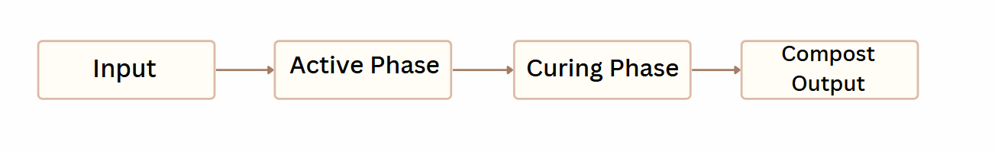
Composting process flow
Features Exposed:
- General shape of 3D model with separate compartments.
- Initial color coding employed to segregate various parts.
- Provisional labeling of active phase and curing phase zones.
- Early motor placement simulation and global composting flow.
- Prepared animations showing lid motion concepts for Sprint 2 (basic lifting animation).
Client Feedback:
- Very positive about overall structure and direction of the solidworks output.
- Asked for some improvements based on new operational demands:
- Add finer animation details (motor clockwise/anticlockwise).
- Alter thickness of lids to 2 cm for insulation.
- Show waste flow between active and curing stages.
- Apply finished colour coding:
- Active Phase – Red, Curing Phase – Green, Finished Compost Collection – Blue
- Named all the sensors correctly (e.g., T1C1, M1C1).
- To improve mixing, updating the internal paddle layout is required.
The client also advised us and shared us the user-friendliness focus for mobile viewing and suggested adding timer simulation for the day and week cycles.
Progress Made Against Plan:
- Base component modelling completed(chambers, pipes, frames).
- Colour-coding Phase 1 (structural parts and large chambers) implemented.
- Basic labelling implemented as per industry standard.
- Basic animations began (lid open/close logic).
- Exportability testing to.GLB/.FBX formats started for integration in future apps.
- Coordinated motor and sensor hardware teams.
Challenges we Faced:
- Trouble in duplicating the physical prototype with the original SolidWorks files because of slight design differences.
- Time constraints during modelling complex parts like paddles and waste channels.
- Minor issues in assembling components in correct formats (3D for mobile apps).
How We Overcame Challenges:
- Organized more online group sessions to accurately compare solidwork measurements.
- Prioritized project task schedule to complete colour coding and labelling in advance.
- Talked to the hardware teams to validate mechanical design assumptions.
- Started modular modelling approach (segmenting animations into manageable smaller pieces).
Sensor locations were labelled but final detailed integration was reserved for Sprint 2.

Retrospect (Critical review of the process)
Meeting Details:
- Date: 25th April 2025 (Friday)
- Time: 5:30 PM
- Venue: Online (Microsoft Teams)
- Attendees: Chrishelle Anthoneyz, Haritha Perera, Thenura Kuruppuarachchi, Senupama Deshapriya
Purpose of the Retrospective Meeting:
The intention of this meeting was to evaluate the group's performance in Sprint 1 critically by taking into account what went right, what went wrong, and identifying areas to improve upon in the upcoming sprint.
Challenges Identified
Challenge | Impact
Underestimation of task difficulty (e.g., animation setup, labeling) | Several tasks required more revisions than were initially expected.
Weekday communication gaps | Minimal confusion over individual task statuses.
Initial unfamiliarity with sensor labeling conventions | Required multiple fixes to fit scientific notation conventions (e.g., CO₂, CH₄).
Risk registry updates were delayed during mid-sprint | Some new risks weren't captured in real time.
Detailed Analysis of Reasons:
- Communication Gaps: On occasions, written daily progress reports were not sent, and thus there was a delay in the reporting of completed components (e.g., model assembly).
- Task Underestimation: At first planning phases, certain tasks like animating lid operations and sensor labeling appeared easier. Detailed client feedback, however, manifested many changes (e.g., adding two lids on top, multiple sensor locations) that required iteration.
- Labeling errors: Proper scientific nomenclature (CO₂, O₂, CH₄) took several cycles of revision to account for variations in formatting.
- Adjustment of Risk Register Update Time Lag: Some of the hardware integration risks (e.g., accuracy of motor placement) manifested later but were not initially included in the risk log, indicating a need for earlier risk update capture.
The team did a superb critical thinking task by critically evaluating strengths and weaknesses of Sprint 1 processes thoroughly. Not only were differences identified but also certain and attainable measures that are connected to improvement will directly improve Sprint 2 performance.
Team Reflection Table
Aspect | Strengths identified | Challenges faced | Improvements Planned
Team Plan | Transparency in task assignment, each member was aware of their role. | Minor workload imbalance during peak weeks (a few members overworked). | Implement weekly check-ins to re-assign work if someone is lagging.
Communication Plan | Active WhatsApp and Discord communication; prompt clarifications. | The infrequent postponement of responding, especially between meetings. | Implement "expected response times" in weeks with active sprints to ensure more fluid flow.
Quality Plan | Careful reading of diagrams, models, and documents prior to submission. | Minor version and file label inconsistency (lack of labels initially). | Enforce version control checklist before submitting documents.
Risk Registry | Risks of team unavailability or technology failures were anticipated in advance. | There were a few unexpected risks (e.g., sensor location confirmation delay) not originally listed. | Increase risk register to capture more detailed project unknowns for the next sprint.
Relevant ethical considerations | Practiced open meetings, noted client comments. | Ethical issues related to labelling of the sensors and client consultation were done after taking feedback. | Begin addressing ethical compliance at the start of each sprint, instead of responding to feedback.

Key Takeaways
- Team Strengths: Active communications, flexibility, and adherence to schedules despite new additions to tasks.
- Key Challenges: Risk planning needed more coverage, and ethics compliance checks through project activity could be enhanced.
- Actionable Plan: Add mini-risk reviews on mid-sprint points, improve internal review process, and maintain ethics focus from project initiation.

Lessons learned (Critical review of SPRINT one experience and future plan)
Key Lessons Learned:
1. Early Cross-Team Collaboration is Critical:
We understood that early and timely communication between hardware teams and the 3D modelling team was imperative. Postponement of checking mechanical structures (e.g., motors, lids) rendered early assumptions invalid.
2. Client Engagement Significantly Shapes Outcomes:
Timely and frequent client feedback sessions revealed real-world specifications (e.g., motion sensor auto-stop safety), which allowed us to correct the model with better accuracy. Early assumptions ignored many operational safety features.
3. Planning and Internal Quality Reviews are Imperative:
Regular checking of 3D models and tasks helped in identifying problems like lid thickness, sensor placement faults, and missing exhaust pipes at an early stage. Delaying it would have involved risking late-stage failures.
4. Accurate Labelling Rules and Colour Coding cause confusion:
Using labels (T1, MC1, etc.) and keeping colour schemes for SolidWorks models and the application interface much reduced internal misinterpretation and ensured higher end-quality.
5. Time Estimation Demands Higher Buffers:
There should have been more time should be allocated for animation adjustments and exporting models. Estimates for intricate tasks (like paddle mix animation) require at least a 10–15% buffer of time.
6. Ethical Sensitivity towards User Safety:
Compliance with ethical practices such as the incorporation of motion sensors (to shut off the motor when lids are left open) was top priority and an important learning experience from both the technical and the ethical sides.
Practical and Feasible Future Suggestions
Area | recommendation | How it will be implemented
Team Communication | Plan hardware–software sync sessions for Week 1 | Continue to hold weekly Discord/Teams stand-up meetings
Client Feedback Integration | Record client feedback immediately in an instant feedback tracker | Collaborative Google Sheet updated after each meeting
Sprint Planning | Pad the estimates by 10–15% on complex tasks | Consider a 'buffer column' while task estimation
Animation and Testing | Run animation and work on sensors held at each phase | Double-check the minute elements before final file export
Safety and ethical compliance | Verify that the motion sensors, lid controls, and gas sensors match the safety requirements | Internal weekly review of safety points checklist
Documentation | Track all the label positions and the sensors thoroughly | Have live annotated 3D model screenshots
Future Focus for Sprint 2:
- Complete all other lids, paddles, and compost motion animations.
- Finalize all labels (sensors, compartments) inside the model.
- Finalize 3D file export testing for the mobile app.
- Start creating a short animated walkthrough video to show in the final.

